|  |
| --- |
| ICIN Bank  Screenshot |

|  |  |
| --- | --- |
| Author | Aman Kumar |
| Purpose | Project Screenshot |
| Date | 22/07/2022 |
| Version | 1.0 |

Version History:

**Backend:**

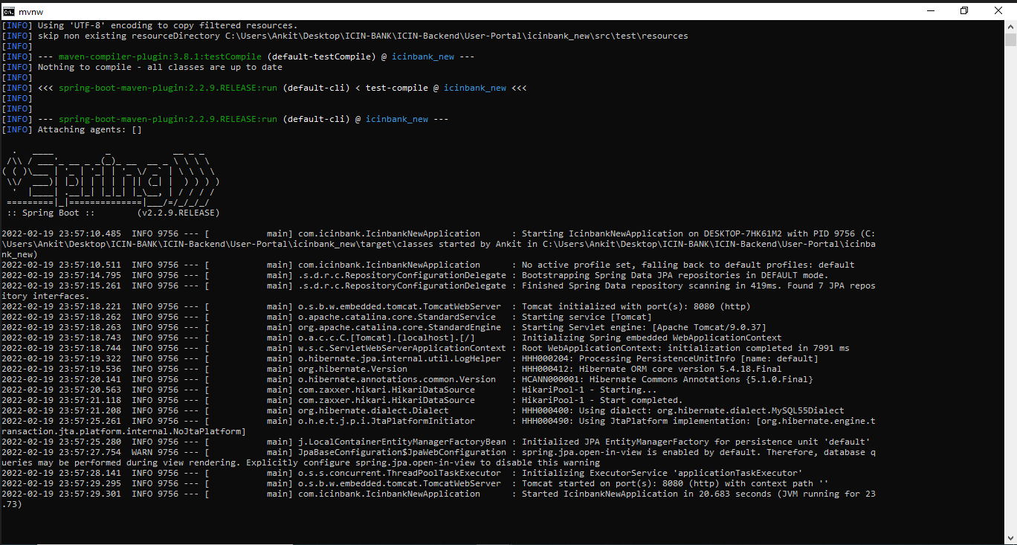

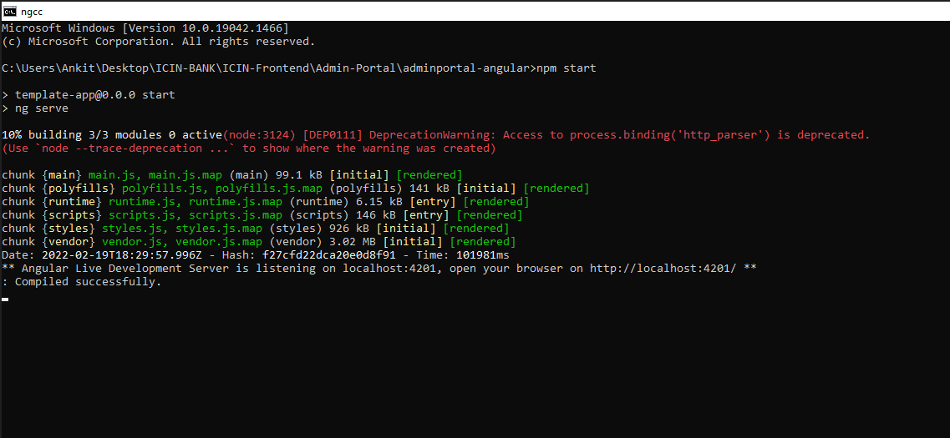**Frontend Admin Portal:**

**Frontend User Portal:**

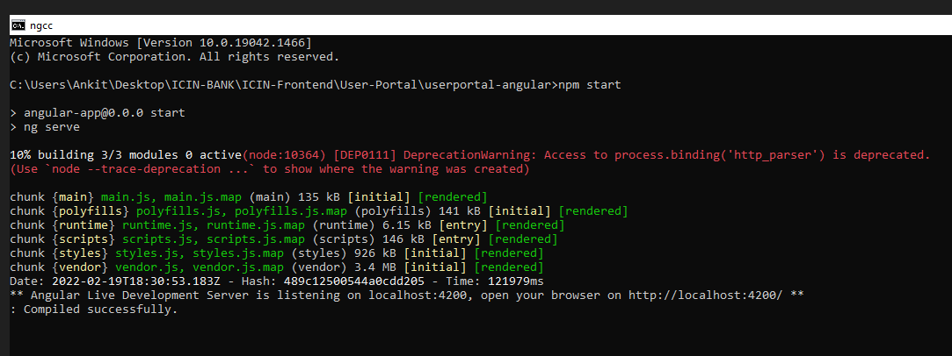

**MYSQL:**

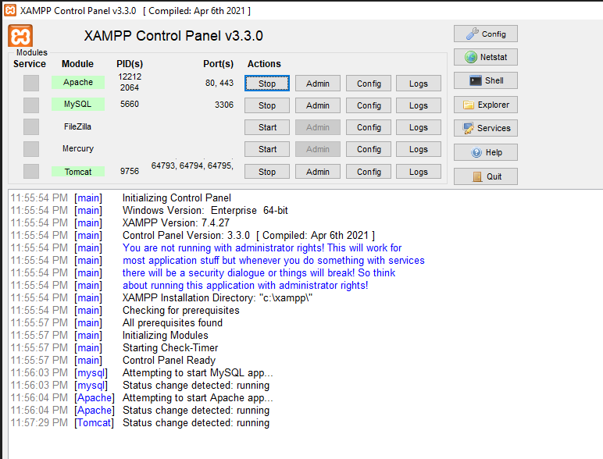

**Database:**

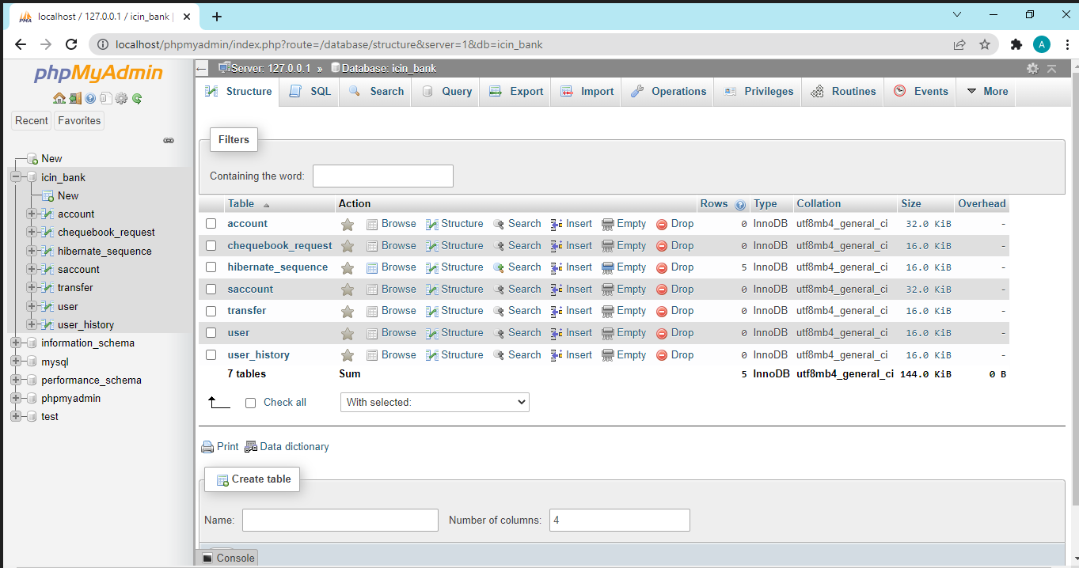

**User Portal:**

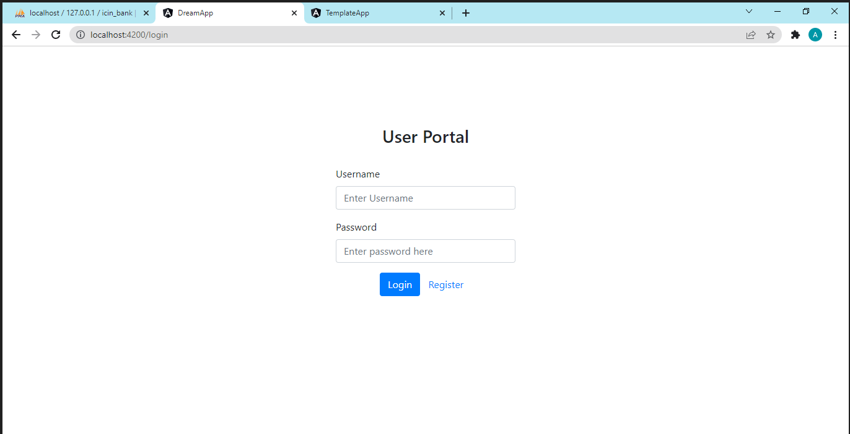

**Admin Portal:**

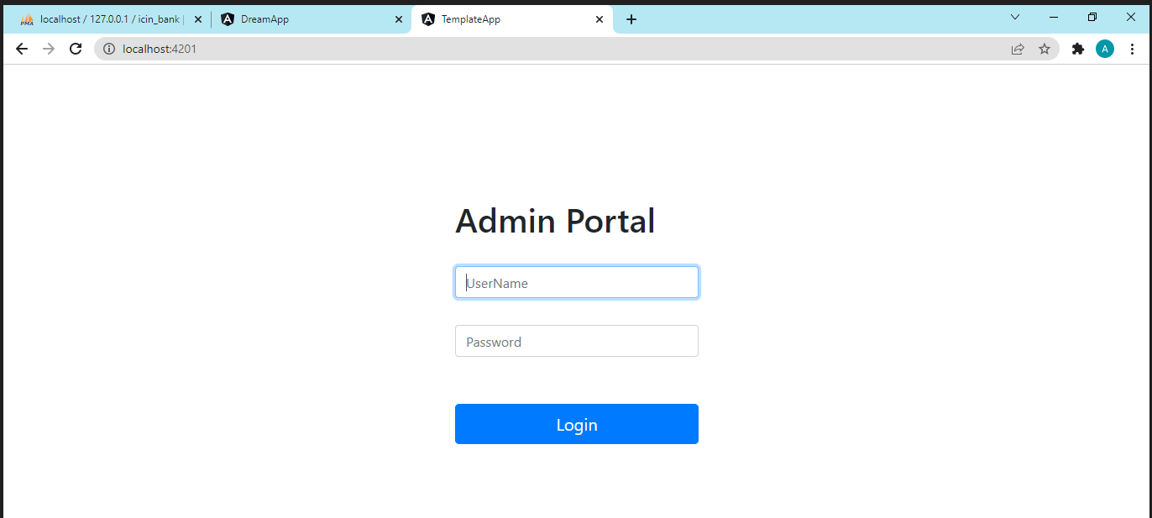

**User Registration Portal:**

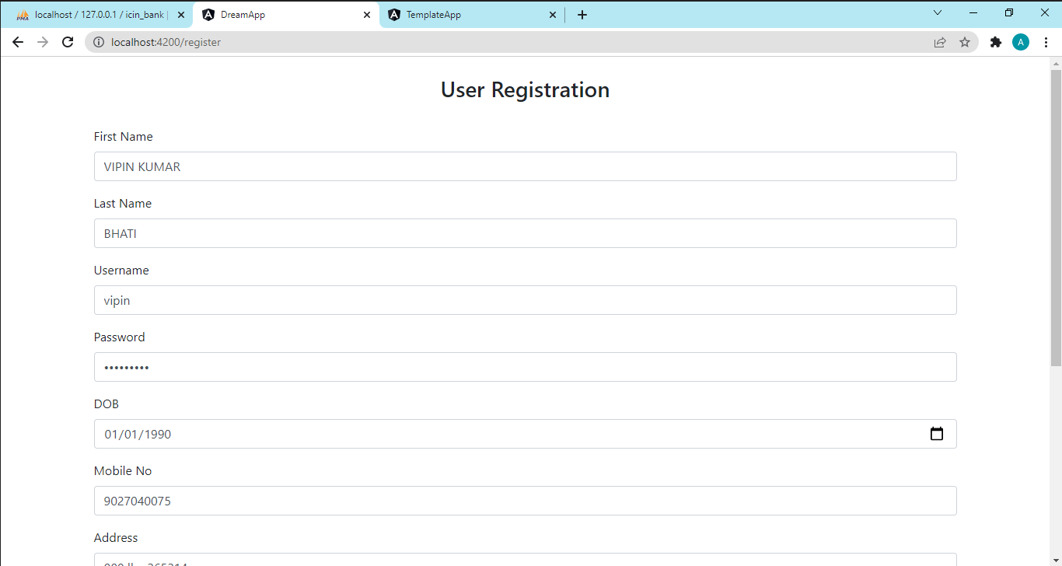

**Registration successful:**

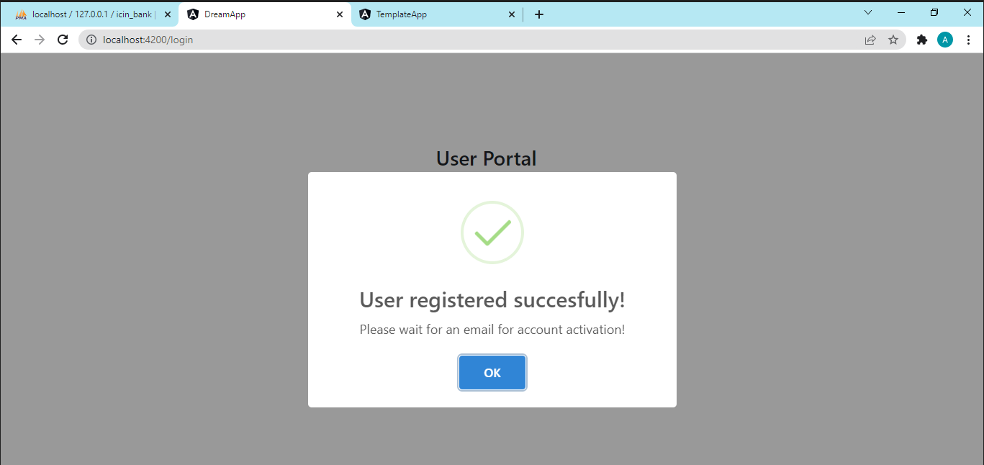

**Admin KYC approval or account creation approval:**

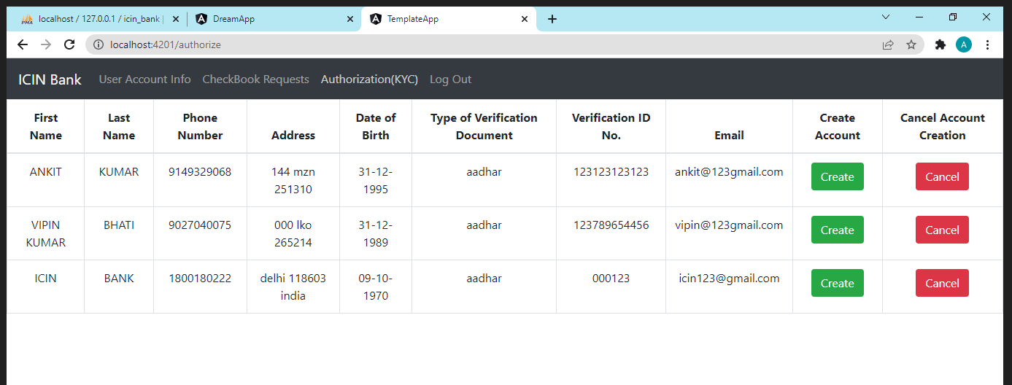

**User account at Admin level:**

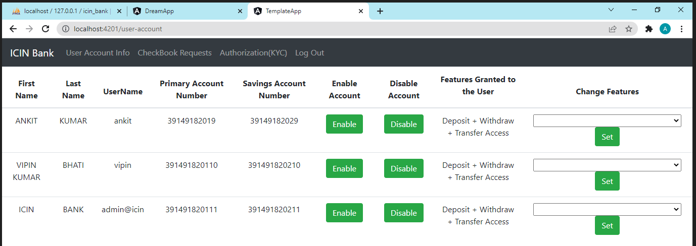

**Database:**

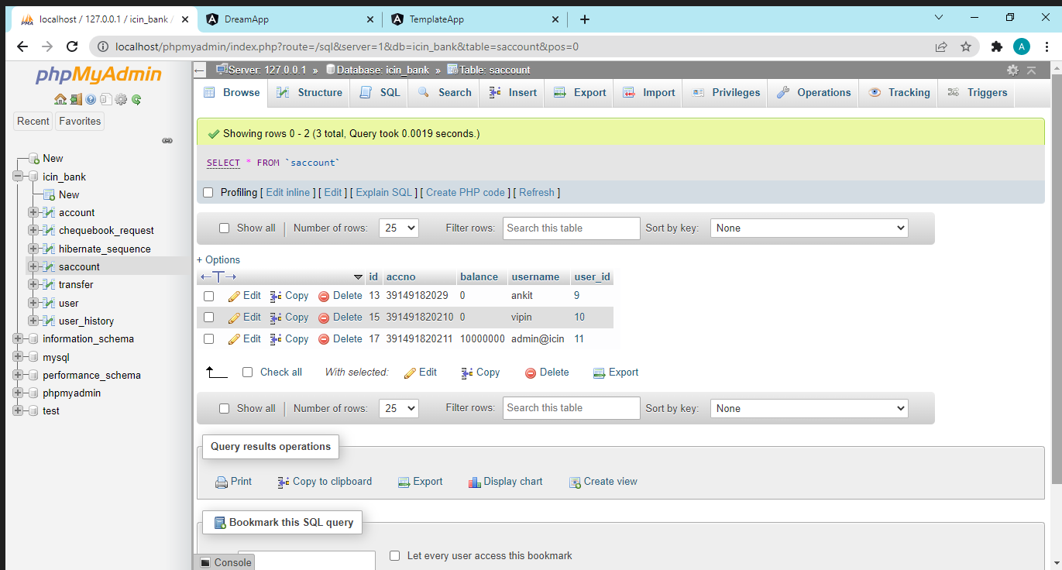

**User Login Portal:**

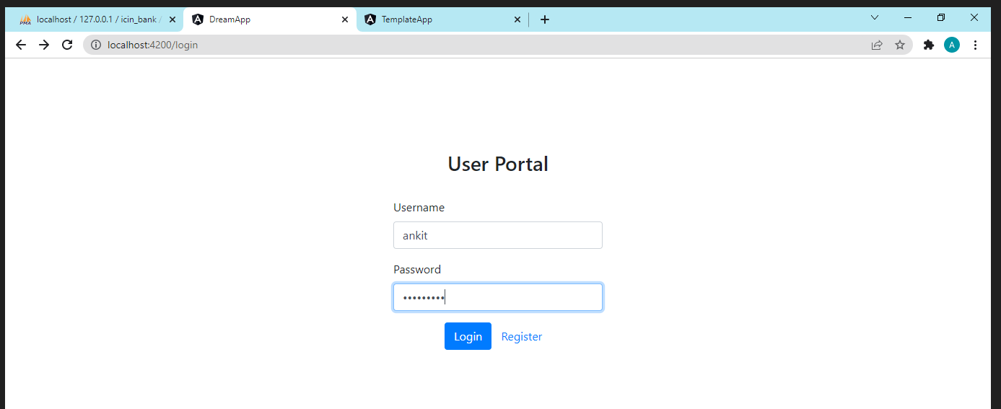

**Login Successful:**

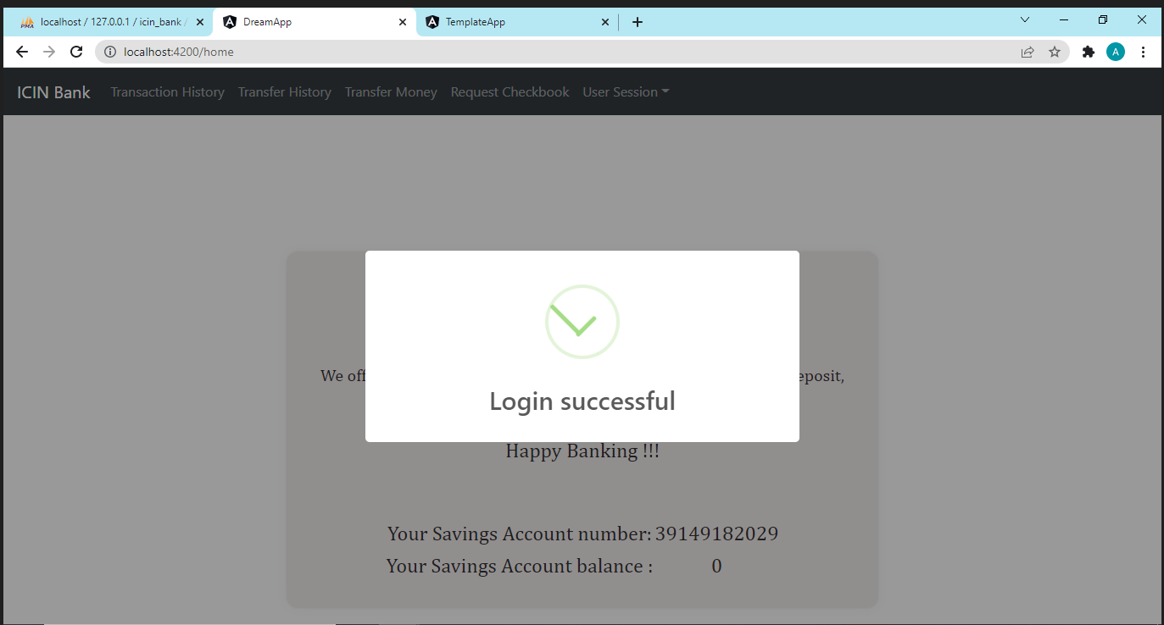

**User Welcome Screen:**

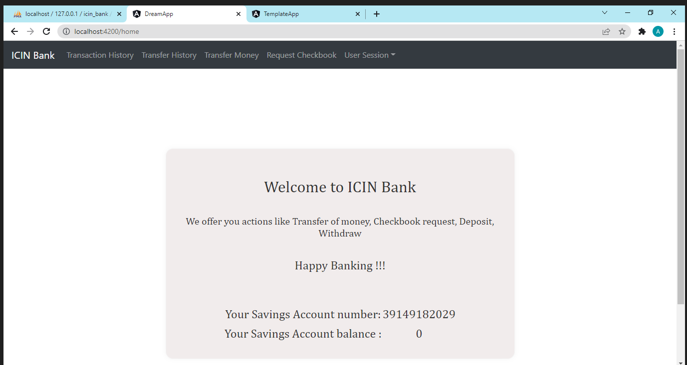

**User Cheque Request Portal:**

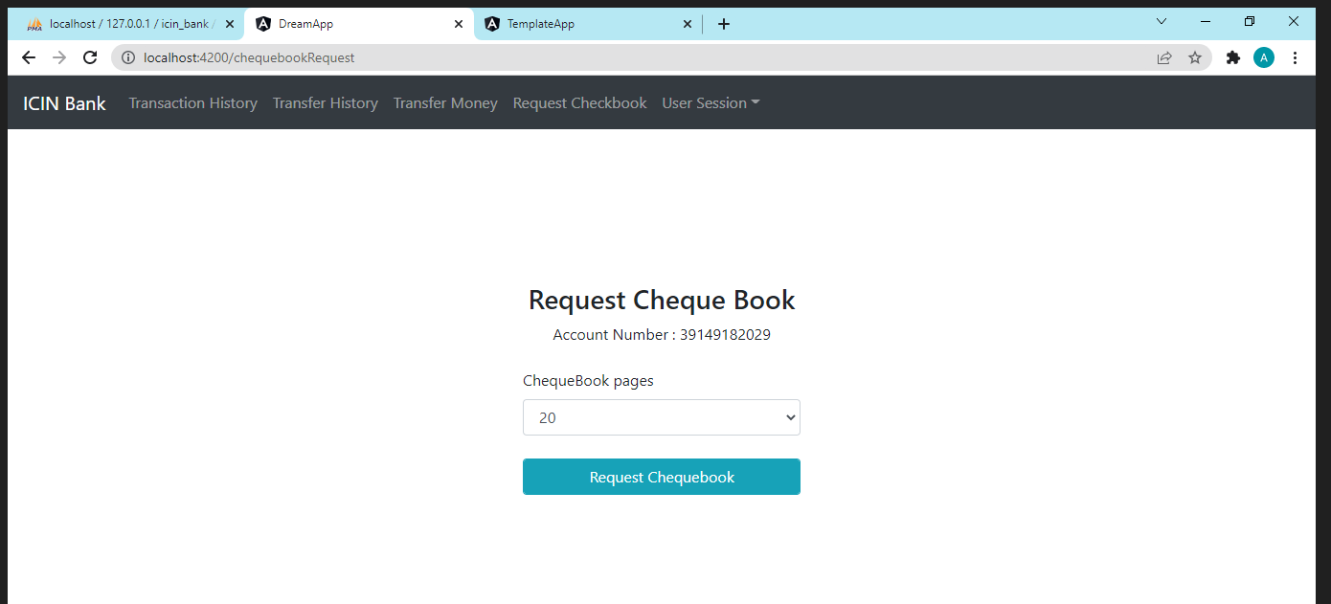c

**Cheque Request Successful:**

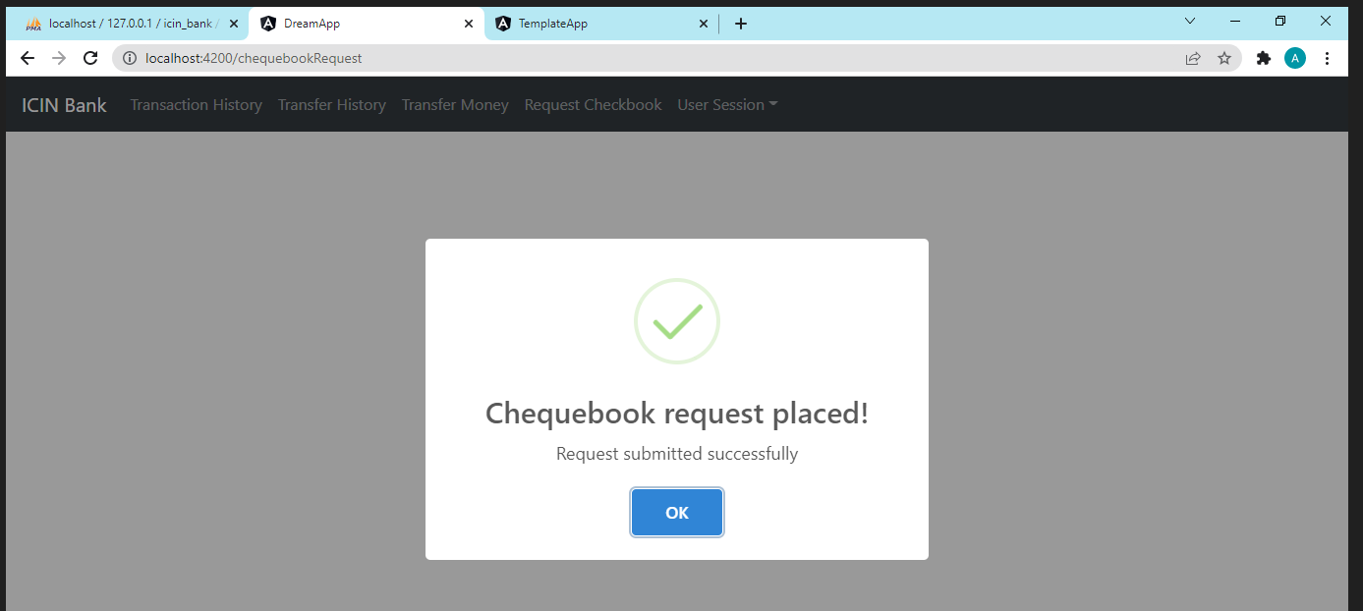

**Admin Login Portal:**

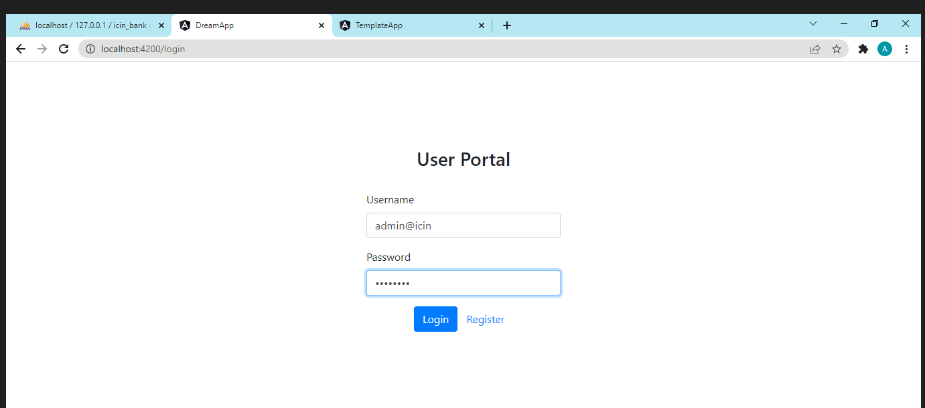

**Admin Cheque request approval portal:**

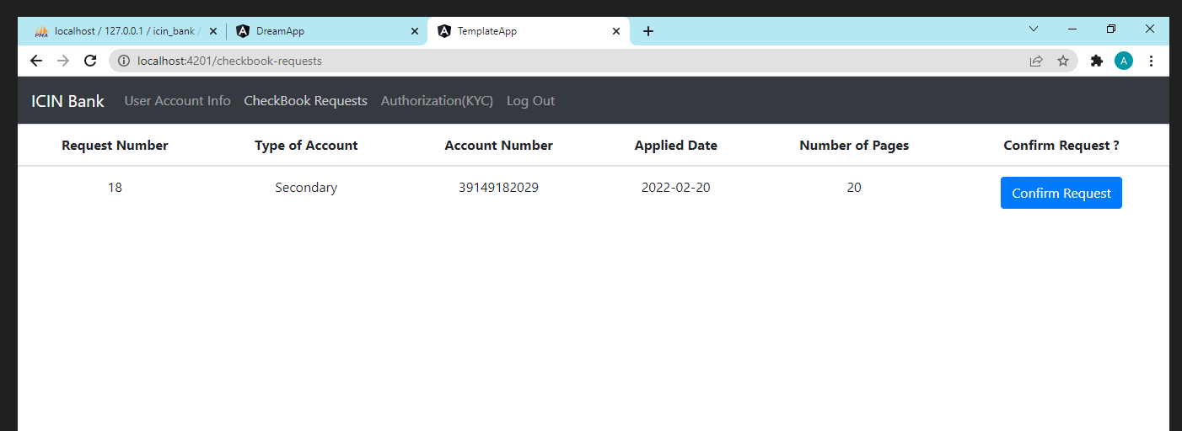

**User Transfer Money Portal:**

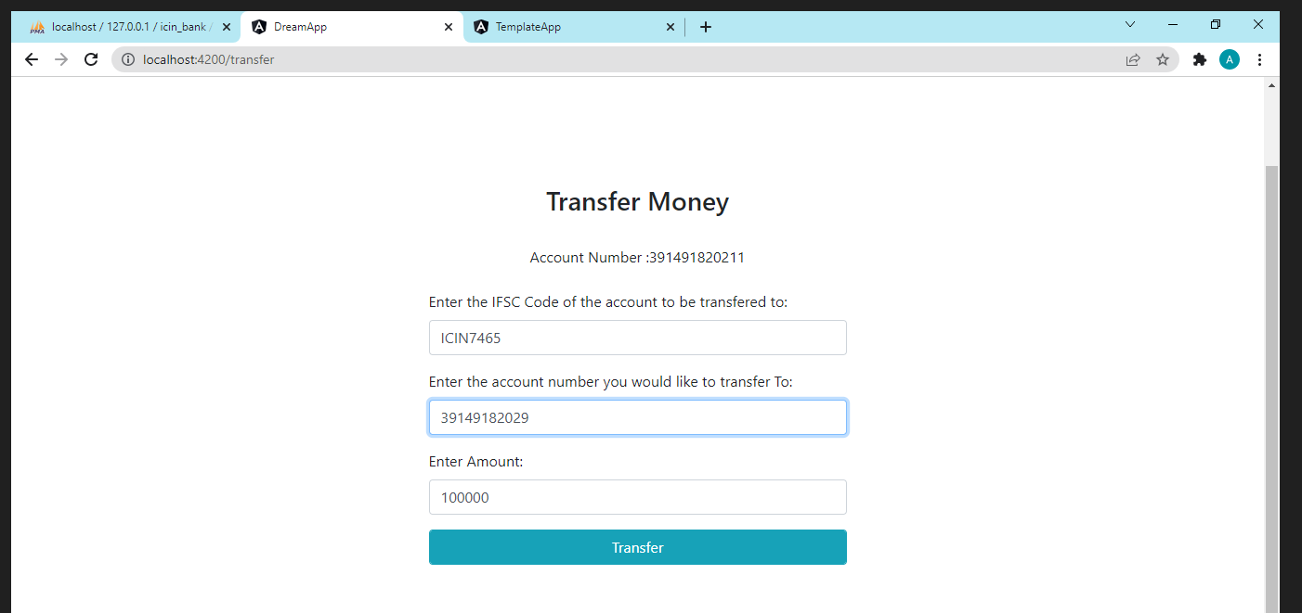

**Money Transfer Successful:**

